**African Gender Classification Using Clothing Identification Via Deep Learning**

**Abstract**

Human attributes identification and classification are popular aspects of computer vision which have been utilized in building relevant innovative systems in recent years. Most of these systems heavily rely on detection and recognition of facial attributes to perform efficiently. This project explores the use of an alternative approach to gender attribute classification of Africans by identifying traditional attires.

Traditional attires are very popular among African societies and reflects a number of attributes such as ethnic background, social status and gender.

The gender attributes of Africans reflected by the visual information of African traditional attires are explored in this project for gender classification.

The AFRIFASHION1600 dataset was utilized in training a model using deep learning techniques. The model achieved 87% accuracy on the test set.

1. **INTRODUCTION**

Facial recognition systems have mostly be employed for gender classification in computer vision over the years. The development of advance tools and concepts in deep learning and computer vision, especially with developing convolutional neural networks to construct maps of facial features or utilizing transfer learning of models pretrained on huge volume of data, has overtime, further enhanced the credibility and resultant reliability of using facial recognition techniques for many forms of attribute identification in computer vision.

However, the use of facial recognition for attributes identification and classification are not without pitfalls as most facial recognition techniques require clear images and high quality videos of clearly defined facial features to be effective [5]. In real life situations, facial images, especially when obtained under non ideal situations, are often distorted, blurred or concentrated on positions that are not appropriate for proper feature detection by facial recognition techniques. For example, common facial recognition techniques are often unable to detect facial features on images where the face is in side view, taken from distance, partially covered or even blurred.

While new innovative techniques, like Google’s Mediapipe facial recognition system are addressing some of these limitations, these are still valid problems today for most facial recognition techniques such as the OpenCV Facial Cascades.

In contrast to facial recognition, clothing identification offer less limitations in gender classification. Though not entirely new, as clothing identification have been employed by humans for gender classification over time immemorial [10], it offers an improved, simple and larger dimensions for gender identification. It is simpler to assume a human wearing a skirt is female and another wearing a Tuxedo is male.

Even though there are unisex clothings with less defined gender boundaries like shirts and trousers which pose classification problems especially in European fashion trends, gender classification by clothing identification is even more narrower in the African fashion system as there are only but a few unisex traditional attires or even none for some African cultures. The Yoruba ethnic society for instance, have distinct cultural attires for both the male and female genders, just like most African cultures, making it possible to rather easily identify genders in traditional attires, even without facial detection, from images taken at relative distances and partially obstructed.

Another reason why clothing identification for gender classification seems quite appropriate for Africans is that most African cultures significantly recognizes only the male and female gender groups, thereby limiting the misclassfication that may arise from non binary gender classes.

Therefore, while gender classification is made complex by the ever increasing gender classes, the more generic and natural male and female gender class system of African cultures simplifies the gender distinction which in result is a boost for classification with deep learning techniques as it eliminates the possibility of multi-label classification complexity.

Rather than totally replace facial recognition systems, clothing identification is best utilized for complementing facial recognition techniques[5] and further enhancing the credibility of human attribute identification using computer vision.

This project aims to build a model using deep learning, to classify the gender of Africans based on their common traditional attires.

1. **The Dataset**

There are quite a number of fashion datasets that have influenced the advances in clothing identification[7]. The most popular being the Fashion MNIST dataset by Xan Hiao et al [4] of 70000 images, the Deep fashion and fashion landmark datasets of 800000 and 120000 images respectively by Liu et al [8, 9] and the Modanet dataset of more than 55000 images by Zheng et al [6].

Due to the afrocentricity of this project, none of the above listed datasets is appropriate for this project , as it requires a dataset that represents African traditional attires, hence the AFRIFASHION1600 dataset was chosen.

The AFRIFASHION1600 dataset, introduced by Wuraola et al [7] in 2021, is currently the only notable contemporary Afrocentric fashion dataset. It contains 1600 (180 x 180 dimensions) RGB sample images that are categorized into 8 classes of fashion styles.

The dataset was further engineered to include 2 gender classes (female and male) that are specific and relevant to this project.

The final form of the dataset used for this project contains a directory of 1600 images of African attires and a comma separated file (CSV) that includes the image IDs, fashion style and gender class columns.

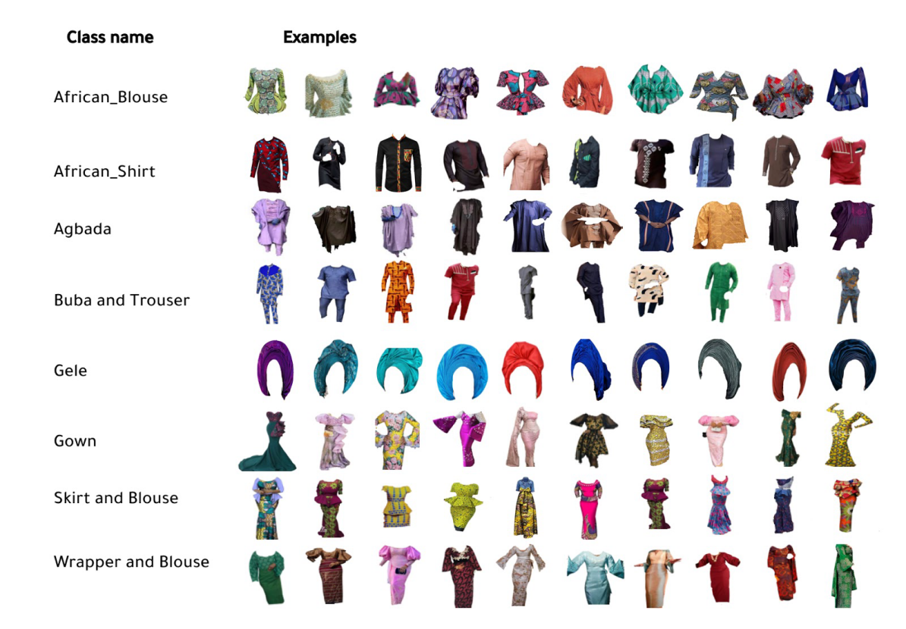

**Figure 1. Class names and sample images for the AFRIFASHION1600 dataset**

Adapted from [7]

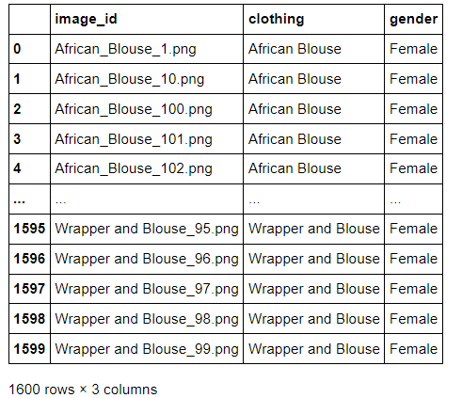

**Figure 2. Preview of image_Ids, fashion labels and gender classes in a dataframe**

Exploratory analysis show that 62.5% of the dataset belonged to the female class while 37.5% belonged to the male class which results in a data imbalance. It is thus expected for the trained classifier to make a biased learning model that could have a poorer accuracy on the male class compared to the female class.

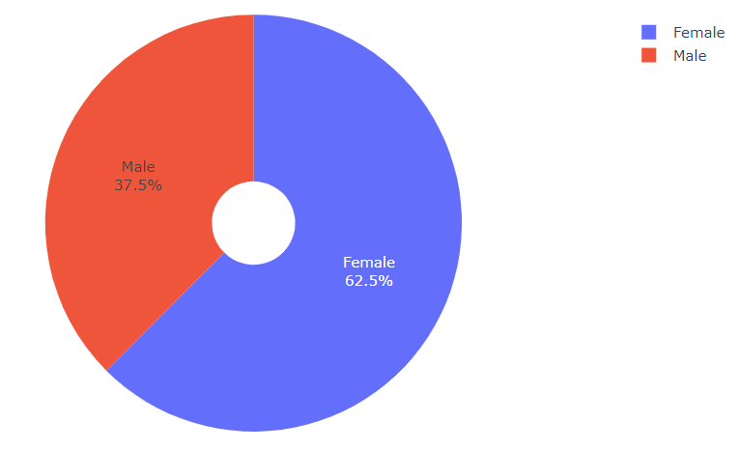

**Figure 3.** **Pie** **Plot of the gender distribution of the dataset**

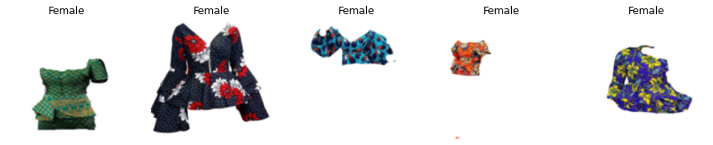

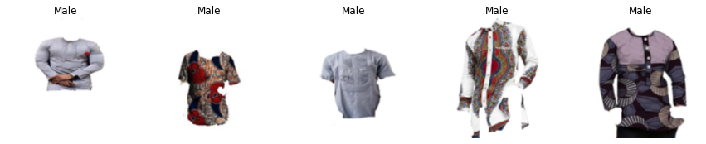

**Figure 4: Sample images from the dataset and their gender labels**

1. **METHODS**

Deep learning image classification techniques were utilized for this project.

80% of the entire data were allocated for training while 10% each where set aside for validating and testing the model.

3.1. Data Preprocessing

Due to the relatively low number of samples, the image data was preprocessed by applying data augmentation to the training set in order to enhance the model accuracy and limit overfitting.

Data augmentation is an image preprocessing technique utilized in computer vision to augment image data of fewer samples. This technique takes the approach of generating more training data from existing training samples, by augmenting the samples via a number of random transformations that yield believable-looking images[3] . The goal of data augmentation is to expose the model to more aspects of the data and generalize better.

This is usually implemented using the *ImageDataGenerator* instance of the Keras library.

The *ImageDataGenerator* instance was used to load the images as array values, apply data augmentation and store the data in generator objects (train, validation and test generators) using a batch size of 128.

3.2 Model Architecture and Classification

Transfer learning technique is utilized for the model building and classification in this project.

This involves the use of saved Convnet models with weights that have have been pretrained on large datasets. The spatial hierarchy of features learned by

pretrained networks have proved useful in other computer vision

problems, even with different class targets[3].

The saved weights of the VGG16 model, pretrained on the Imagenet dataset were specifically used in this project. The VGG16 is a convolutional neural network proposed by A. Zisserman[1] . Convolutional neural networks are deep learning models that are often used for computer vision problems. They are networks of deeply connected neural layers that perform spatial filtering, convolution, back-propagation and gradient descent operations on image inputs for image classification.

The input to the first layer (Conv1) of the original VGG16 model is of a fixed size 224 x 224 RGB image. The image is passed through a stack of 24 layers, with series of 3x3 and 1x1 shaped filters. Spatial pooling is carried out by 5 Maxpooling layers (of size 2x2 and stride of 2) which follows only some of the Convolution layers.

The final two layers are a 1000 channels Convolution layer (for each class of the Imagenet dataset) and a Softmax layer for multi-class classification[1].

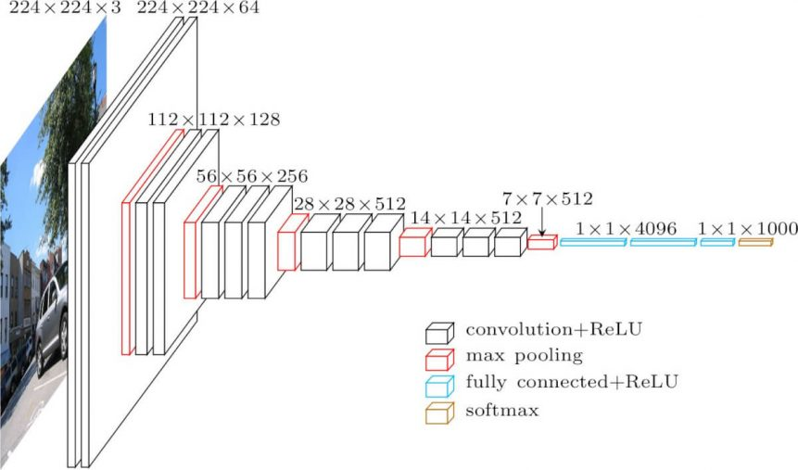

**Figure 5. VGG16 model architecture**. Adapted from [1]

The top layers of the model were not included due to the difference in the number of classification targets and size of the input images. The last 4 layers of the model were also unfreezed to allow the model learn features specific to this image classification project while utilizing the features learned from the Imagenet dataset.

Newly defined Flatten, Dropout (for regularization) and output layers (with Sigmoid activation function) were added to the modified VGG16 model.

Sigmoid activation functions are commonly used for binary classification to map the probability of outputs between 0 and 1, with positive outcomes for values greater than 0.5 and negative for those below.

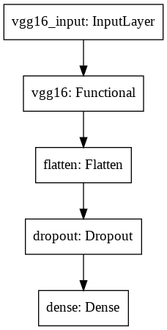

**Figure 6. Architecture of the model**

3.3 Model Training

The training sets, now stored in data generators of 128 batch sizes were used to train the model for 50 epochs while validating the model using the validation set with training and validation steps of 13 iterations per epoch. The batch size is the number of samples that are propagated through the network for each forward pass and weight adjustment.The batch size helps to implement the mini batch gradient descent which is used for this project.

The training and validation steps (result of dividing the number of samples by the batch size) defines the number of iterations it takes to propagate all the samples through the back propagation algorithm, given it propagates a batch of the samples in each iteration.

The epochs describes the number of times the algorithm process the entire dataset. An epoch is completed when the number of steps required to propagate the entire dataset at batches is complete.

Callbacks were defined to utilize monitoring the validation loss for saving the best weights, reducing the learning rate at intervals and stopping the training if there weren't any learning after few epochs.

3.4 Model Evaluation

After 50 epochs of training, the model achieved a 90% accuracy on the train set with a minimum loss of 0.18 and a 89% accuracy on the validation set with a minimum loss of 0.25.

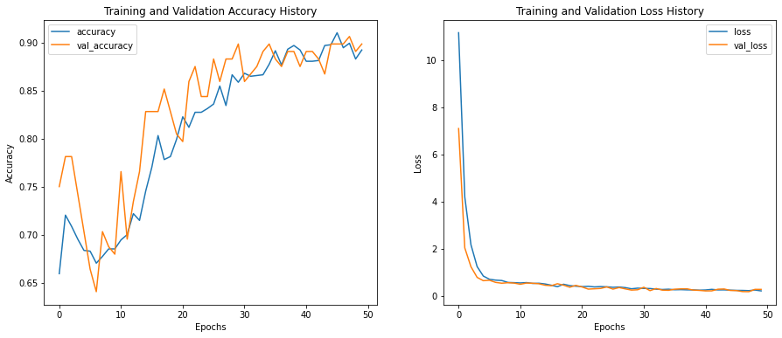

**Figure 7. Performance of the model on the train and validation sets.**

The model also achieved an 87% accuracy on the test set. A confusion matrix evaluation showed that while the model is biased towards the female class, it still showcased good predictiveness for both classes.

The confusion matrix is a useful visualization of performance measurement for classification algorithms.

It shows the model’s performance in terms of true and false positive and negatives in the test set evaluation.

The true positive is the number of correctly predicted samples for the positive class while the false positive is the number of wrongly predicted samples for the same positive class (female).

The false negative is the number of wrongly predicted samples for the negative class (the not female class, which is the male class) while the true negative is the number of rightly predicted samples for the same negative class.

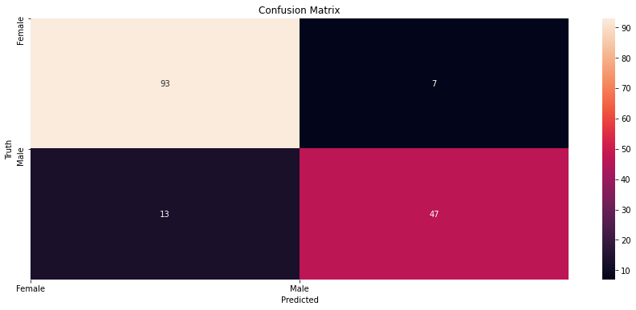

**Figure 8. Confusion matrix of test set evaluation**

Only 7( false positive) out of the 100 female test samples were misclassified ( 93% precision) while 13( false negative) of the 60 male test samples were misclassified (78% precision) .This disparity in precision is as a result of data imbalance.

A classification report is also useful in measuring the quality of of the prediction from a classification algorithm.

The precision defines the ratio of the true positives or correct prediction to the number of samples in the class.

The recall defines the ratio of the true positive instances to the sum of the true positives and false negative. It describes the ability of the classifier to correctly predict positive instances.

The F1 score describes the ratio of correct positive instances. It is the harmonic mean of the precision and recall.

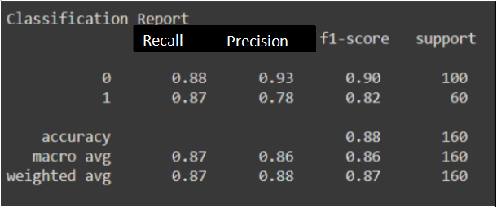

**Figure 9. Classification report for the test set evaluation**

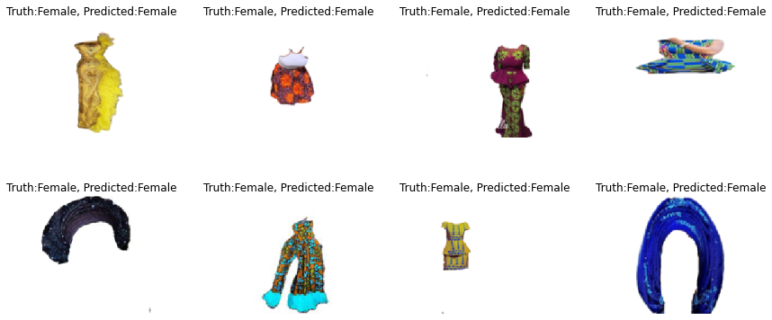

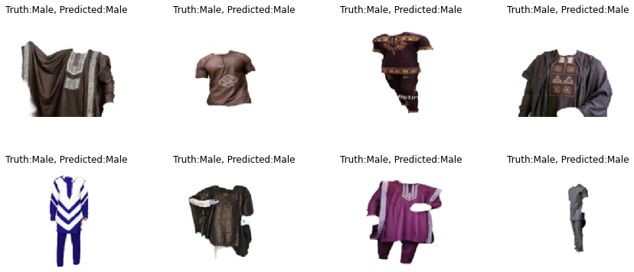

**Figure 10. Comparing the truth and predicted labels for sample images**

1. **Discussions**

The model’s evaluation metric values are useful in measuring the performance and reliability of the model.

The average scores of 89% and 87% on the validation and test sets respectively proves a high predictive ability of the model in identifying the clothing for both genders.

The model’s precision values for both classes show that the model performs better in predicting the correct class of female fashion samples than for male samples ( with precision scores of 93% to 78%). This is as a result of imbalance in the dataset (62.5% to 37.5%).

The relatively low loss values for both validation and test sets and high recall values suggest that model is less prone to missclassify the fashion samples, especially for the dominant female class whose performance contributes to the desired loss value than the male class .

The F1 scores of 90% for the female class and 82% for the male class are good enough to suggest a decent credibility and robustness of the model as it considers a balance between the precision and recall metrics.

These metric values also mean that the model is a good fit and appropriate to train on the data as it only slightly overfits, helped by the dropout regularization technique utilized in building the model.

Also, despite the training set having few samples ( 1280 samples) to properly train an image classifier using deep learning, the relatively high metrics scores achieved could be attributed to the learned weights of the pretrained model, which trained on the Imagenet dataset that also contained fashion samples and also to the clearly defined, high quality sample images used in training the model.

While the evaluation sets (validation and test sets) relatively have fewer values to properly ascertain the credibility and robustness of the model, it could be suggested that the model performs fairly well in rightly classifying the gender labels for traditional African attires at least.

There is no doubt that the model would greatly benefit from training from much more samples, especially for the less represented male class.

1. **Conclusion**

A model was trained on the AFRIFASHION1600 dataset in this study to rightly classify the gender of Africans by identifying their clothing.

The model achieved a satisfactory accuracy of 87% on the test set given the low amount of training samples.

Much more training and evaluation samples that balances the dataset and represents diverse African cultures would be required to achieve a more relevant and innovative gender classification system.

**References**

1. Andrew Zisserman and Karen Simonyan. Very deep convolutional networks for large scale recognition.205.arXiv:1409.1556[cs.CV]
2. Feis R, Bobbit R, Brown L, et al. Attribue -based people search: Lessons learnt from a practical surveillance system. International Conference on Multimedia Retrieval; 2014 Apr 1-4; Glasgow, UK: ACM Press; 2014; p. 153-160.
3. Francois Chollet. Deep Learning with Python. Mannings Publications. 2018.

Pages 117 -178.

1. Han Xiao, Kashif Rasul, and Roland Vollgraf, Fashionmnist: A novel image dataset for benchmarking machine learning algorithms. arXiv preprint arXiv:1708.07747, 2017.
2. Marianna Bedeli, Zeno Geradts & Erwin van Eijk (2018) Clothing identification via deep learning: forensic applications, Forensic Science Research, 3:, 219-229, DOI:10.1080/20961790.2018.15262551.
3. Shuai Zheng, Fan Yang, M Hadi Kiapour, and Robinson Piramuthu. Modanet: A large-scale street fashion dataset with polygon annotations. In Proceedings of the 26th ACM international conference on Multimedia, pages 1670-1678, 2018.
4. Wuraola Oyewusi, Olubayo Adekanbi, Sharon Ibejih, et al (2021) AFRIFASHION1600: A Contemporary African Fashion Dataset For Computer Vision. Conference on Computer Vision and Pattern recognition (CVPR), June 2021; pages 4321- 4325.
5. Ziwei Liu, Ping Luo, Shi Qui, Xiaogang Wang, and Xiaoou T. ang. Deepfashion: Powering robust clothes recognition and retrieval with rich annotations. In proceedings of IEEE Conference on Computer Vision and Pattern recognition (CVPR), June 2016.
6. Ziwei Liu, Sijie Yan, Ping Luo Xiaogang Wang, and Xiaoou T. ang. Fashion landmark detection in the wild.European Conference on Computer Vision, pages 229-245. Springer, 2016.
7. Zoi Arvanitidou & Maria Gasouka (2013) Construction of gender through fashion and dressing. Mediterranean Journal of Social Sciences, DOI:10.5901/mjss.2013.v4n11p111.
8. Nash, Will & Drummond, Tom & Birbilis, Nick. (2018). A review of deep learning in the study of materials degradation. npj Materials Degradation. 2. 10.1038/s41529-018-0058-x.